**Docker Task -3**

**Task Description:**

Create a custom docker image for nginx and deploy it using docker compose, where the volume bind mount should be at /var/opt/nginx location. Push the created custom docker image to your docker-hub.

**Step 1:** Create a EC2 instance

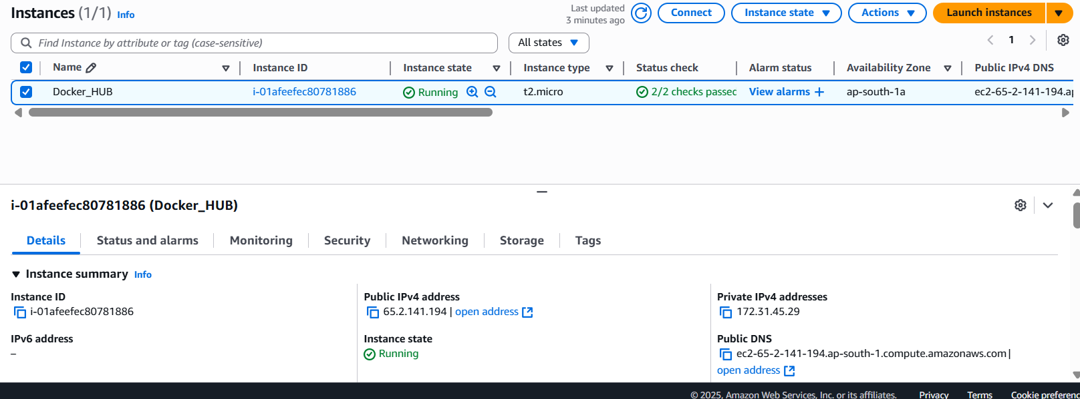

**Step 1: Create the Docker image**

**Step 1: Create the Docker image**

Step 2 :Create Docker images  
  
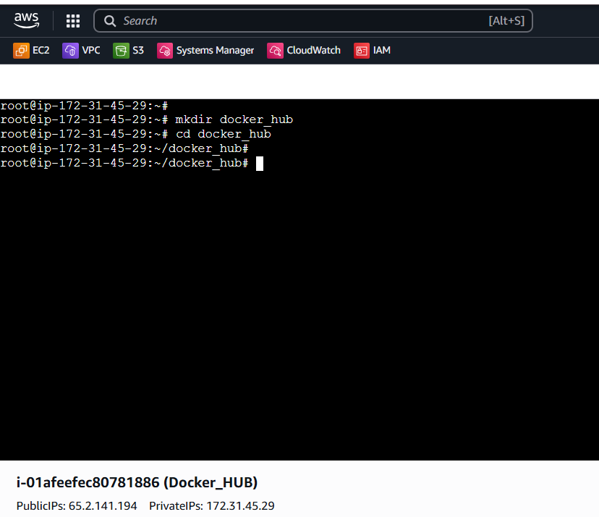

Step 3:Pull the docker image

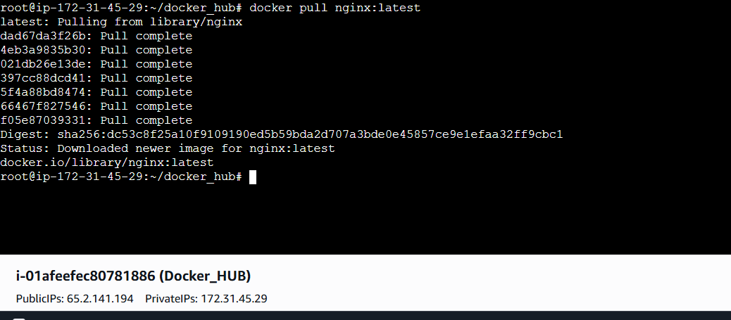

**Step 4: Verify that the NGINX image was pulled successfully**

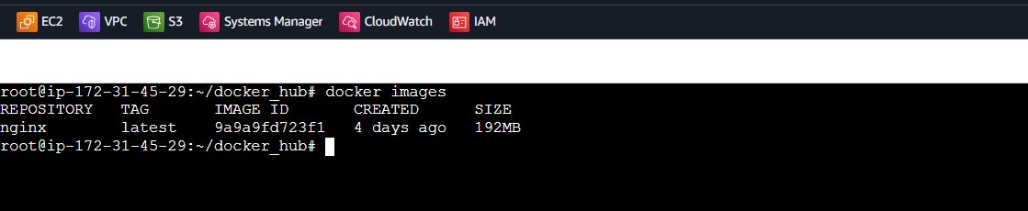

**Step 5: Create the Dockerfile and Index.HTML**

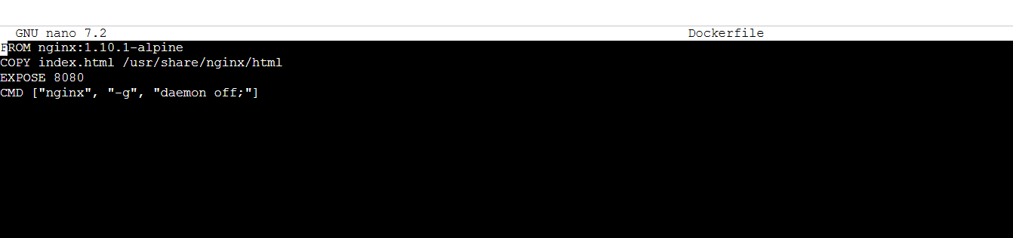

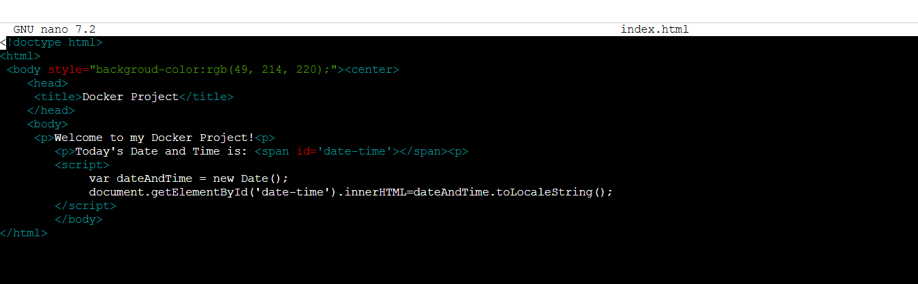

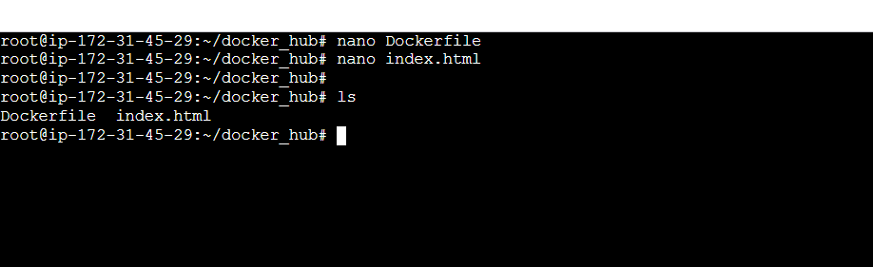

**Step 6: Build the image**  
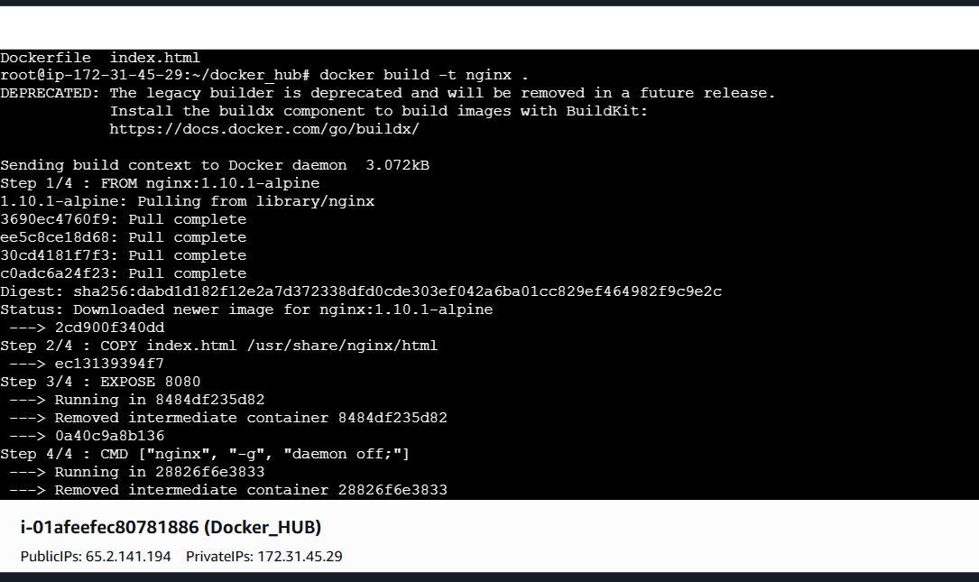**Step 7: Build and deploy the container**

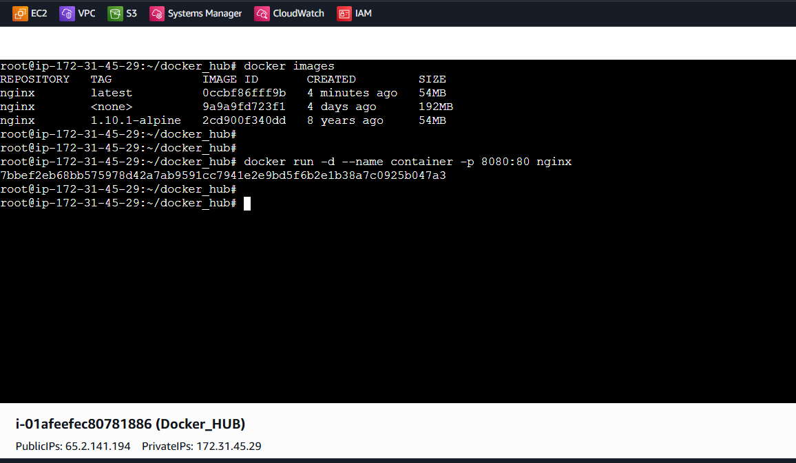

**Step 8: Verify that the container is running**

**Step 8: Verify that the container is running**  
  
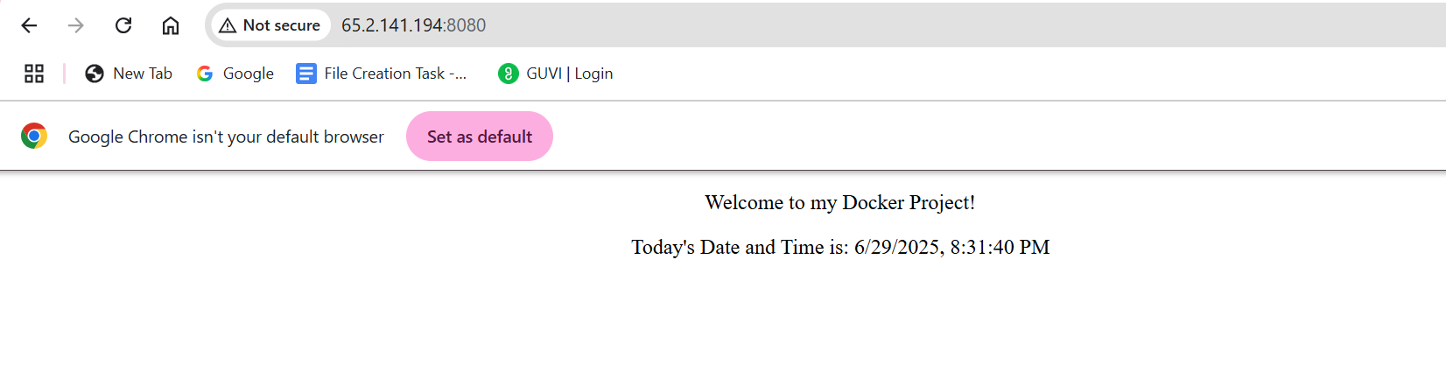

**Step 9:Push the image to Docker Hub**

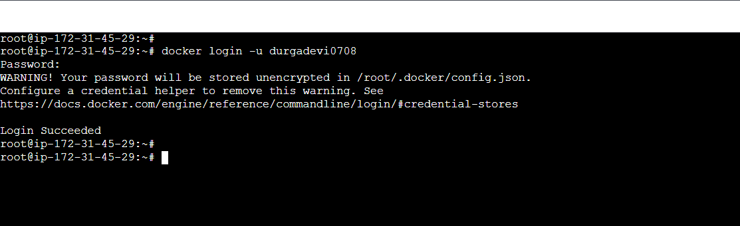

**Step 10: Create a Repository in Docker**

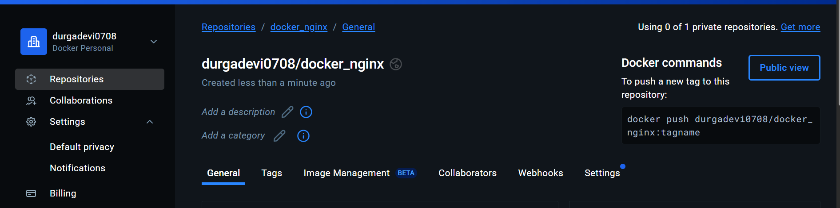

**Step 11: Commit the image and Push the image to Docker Repo**

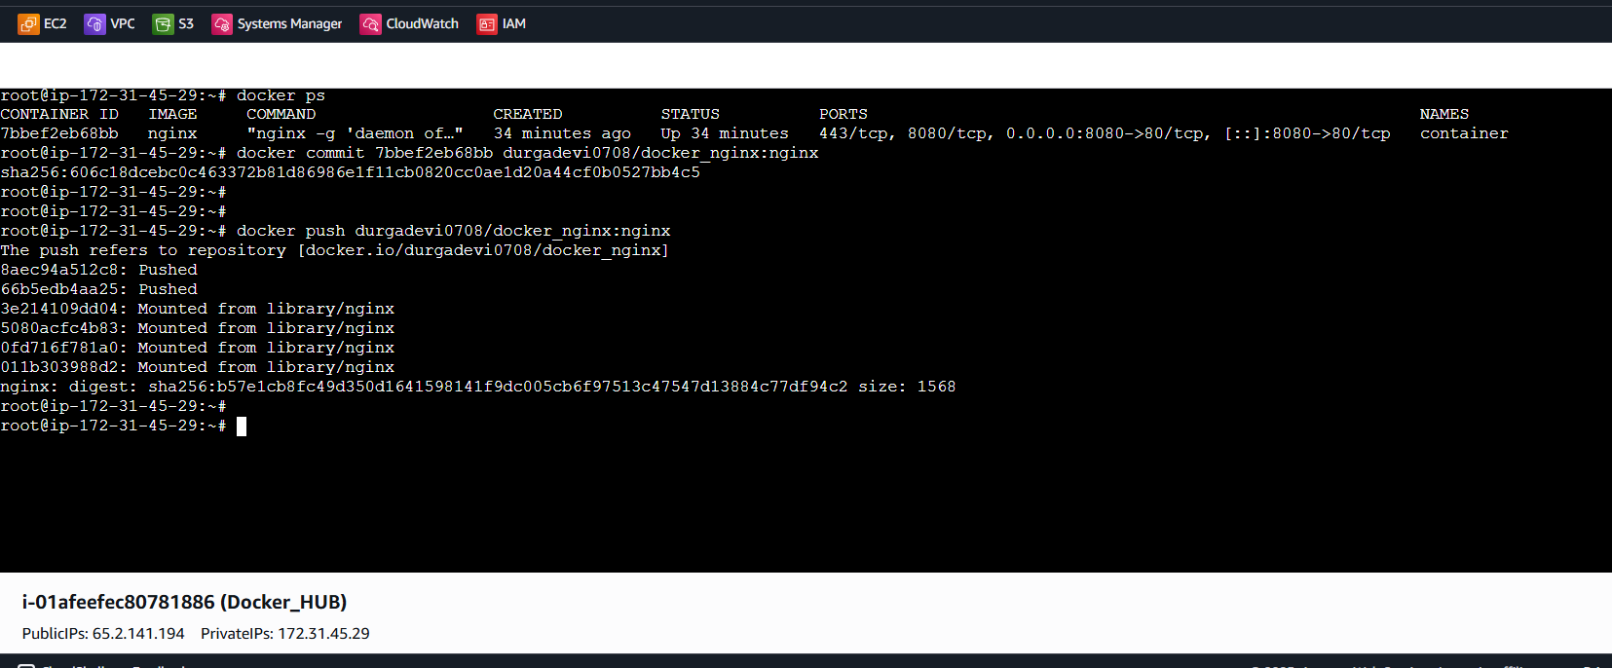

**Step 12: Verify if the image was pushed**

